

The 7th ASEM Education Ministers' Meeting (ASEMME7)

“Connecting education: inclusion, mobility and excellence
in support of the Sustainable Development Goals”

15 - 16 May 2019, Bucharest, Romania

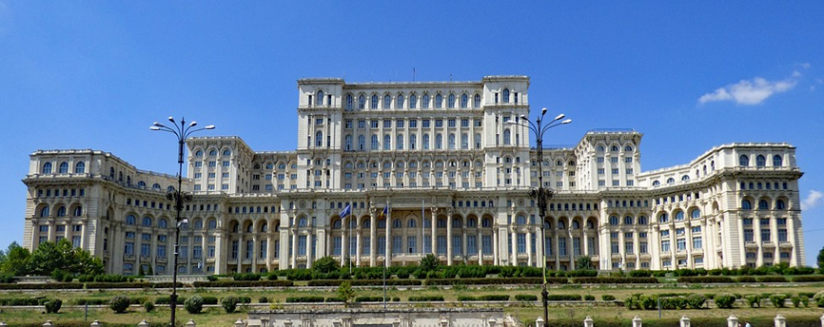

 | 
Ministry of National Education of Romania | Romanian Presidency of the Council of the European Union

The 7th ASEM Education Ministers' Meeting (ASEMME7)
“Connecting education: inclusion, mobility and excellence
in support of the Sustainable Development Goals”

Agenda

Wednesday, 15 May 2019 (ASEMME7 – Day 1)
Venue: Palace of the Parliament, I.C. Bratianu Hall

09:00 – 13:30 Registration of participants – Entrance lobby
Bilateral and Working Group Meetings (by appointment only) – Take Ionescu Hall/ Human Rights Hall

12:30 – 13:30 Lunch – Brancovenesc Hall

13:30 – 14:00 Welcome speeches – I.C. Bratianu Hall
Representative of the Romanian Government (tbc)
Mrs Ecaterina ANDRONESCU, Minister of National Education,Romania

14:00 – 14:30 Introduction speeches – I.C. Bratianu Hall
Mr Tibor NAVRACSICS, Commissioner for Education, Culture, Youth and Sport, European Commission
Assoc. Prof. Sophon NAPATHORN, Vice-Minister, Ministry of Education of Thailand
Mr Remus PRICOPIE, former Minister of National Education of Romania, Rector of the National University of Political Science and Public Administration (SNSPA) - the host of the 7th ASEF Rectors' Conference and Students' Forum (ARC7) – ARC7 Policy Recommendations

13:30 – 14:30 Discussion chaired by Mr. Sorin CÎMPEANU, former Minister of National Education of Romania, Rector of the University of Agronomy in Bucharest (USAMV)

14:30 – 15:30 Family Photo -1st floor lobby

Press conference – Nicolae Iorga Hall
Mrs Ecaterina ANDRONESCU, Minister of National Education, Romania
Mr Tibor NAVRACSICS, Commissioner for Education, Culture, Youth and Sport, European Commission
ASEM Education Secretariat

Guided tour of the Palace of the Parliament
Coffee Break – Take Ionescu Hall

15:30 – 17:00 Plenary Session I – I.C. Bratianu Hall
Mobility for everyone: balanced and inclusive mobility in the digital era

- Asia
H.E Mr. Park Baeg Beom, Vice Minister of Education, Republic of Korea - Education policies in Korea for inclusion and innovation
H.E Mr. Mohamad Nasir, Minister of Research, Technology and Higher Education, Republic of Indonesia

- Europe
H.E. Mr. Evarist Bartolo, Minister for Education and Employment Malta,
H.E Mr. Christian Luft, State Secretary (Deputy Minister of Education), Federal Ministry of Education and Research, Germany

17:00 – 17:30 Chair’s Conclusions: presentation
I.C. Bratianu Hall

15:30 – 17:30 Discussion chaired by Mr Remus PRICOPIE, former Minister of National Education of Romania, Rector of the National University of Political Science and Public Administration (SNSPA) - the host of the 7th ASEF Rectors' Conference and Students' Forum (ARC7) – ARC7 Policy Recommendations

Transfer to the hotel
20:00 – 22:00 Official dinner at the National Bank of Romania

Thursday, 16 May 2019 (ASEMME7 – Day 2)
Venue: Palace of the Parliament, I.C. Bratianu Hall
Working meeting for ministers/ vice-ministers/ state secretaries/ deputy state secretaries/ European Commission - Human Rights Hall  Chair: Mrs Irina KOVÁCS Secretary of State, Ministry of National Education, Romania  Presentation of ASEM Connectivity portal – Mr. William Becker, European Commission - Joint Research Centre  Informal political discussion on the Bucharest Ministerial Statement | Presentations of ASEM partners and stakeholders - I.C. Bratianu Hall  Chair: Alexandra Angress, Aschaffenburg Technical University of Applied Sciences  - Mr. Martin Schifferings, DAAD, Germany - What is the potential of Virtual Mobility within the AEP?  - Mr. Seamus O’Tuama, University College of Cork, Ireland - What are relevant research topics for the LLL HUB in order to contribute to the transversal themes of Digitalisation and Sustainable Development?  - Assoc. Prof. Dr. Houngphet Chanthavong, Vice President, National University of Laos - How can universities contribute to SDG’s? How can the AEP support universities in the realisation of SDG’s and vice versa?  - Ms. Chantavit Sujatanond, Centre Director (SEAMEO-RIHED) - virtual collaboration and MOOCs in South East Asia and how can the AEP stimulate virtual collaboration and the development of MOOCs in SE Asia?  - Mr. Amir Piric, Chief Programme Coordinator, UNESCO Institute for Lifelong Learning (UIL) - Why can Learning Cities contribute to Digitalisation and Sustainable Development? What can be the role of the AEP to in the development of Learning cities and what can be the role of Learning Cities in the AEP?

9:00 – 10:15 Parallel sessions

10:15 – 10:45 Coffee Break – Take Ionescu Hall

10:45 – 12:30 Plenary Session II – I.C. Bratianu Hall
Towards the Agenda 2030 for Sustainable Development: How can the ASEM Education Process contribute?

- Europe
H.E. Mr. Nadhim Zahawi, Minister, Department for Education, United Kingdom - Towards the Agenda 2030 for Sustainable Development: How can the ASEM Education Process contribute?
H.E Dr. philol. Ilga Suplinska, Minister of Education and Science, Latvia

- Asia
H.E Mr. Natalia Bocharova, Vice-Minister of Science and Higher Education, the Russian Federation
H.E. Mr. Undersecretary Revsee Escobedo, Vice Minister, Department of Education, the Philippines.

10:45 – 12:30 Discussion chaired by Mr. Adrian CURAJ, former minister of education, head of the Executive Unit for Financing Higher Education, Research, Development and Innovation (UEFISCDI) – as co-organizer

12:30 – 13:00 Adoption of the Chair’s Conclusions and presentation of the Bucharest Ministerial Statement – I.C. Bratianu Hall

13:00 – 13:15 Closing remarks – I.C. Bratianu Hall

12:30 – 13:15 Discussion chaired by Mrs Irina KOVÁCS Secretary of State, Ministry of National Education, Romania

13:15 – 14:30 Lunch – Brancovenesc Hall

14:15 – 15:00 Bilateral and Working Group Meetings (by appointment only) – Take Ionescu Hall/ Human Rights Hall

15:00 – 16:30 Cultural visit - Guided walking tour of Bucharest (optional)

